OUTPUT:

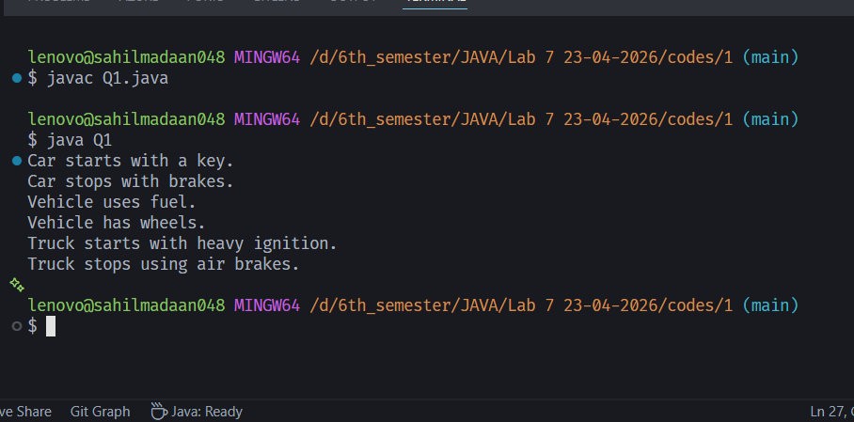

LAB 7
- Write an Abstract Class Vehicle having 4 methods (mix of concrete and abstract methods) to achieve 50 % abstraction. Provide the implementation of abstract class in subclasses, say Car and Truck.
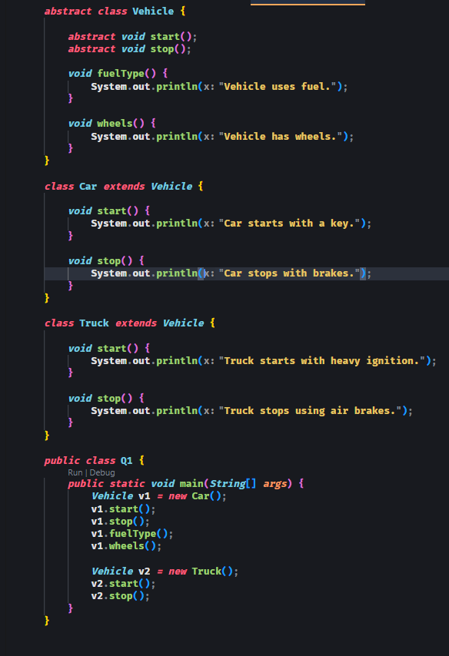

OUTPUT:

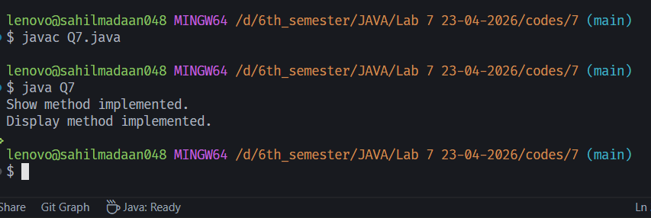

LAB 7
- Write a program to demonstrate that abstract classes cannot be instantiated, but can be referenced using superclass references.

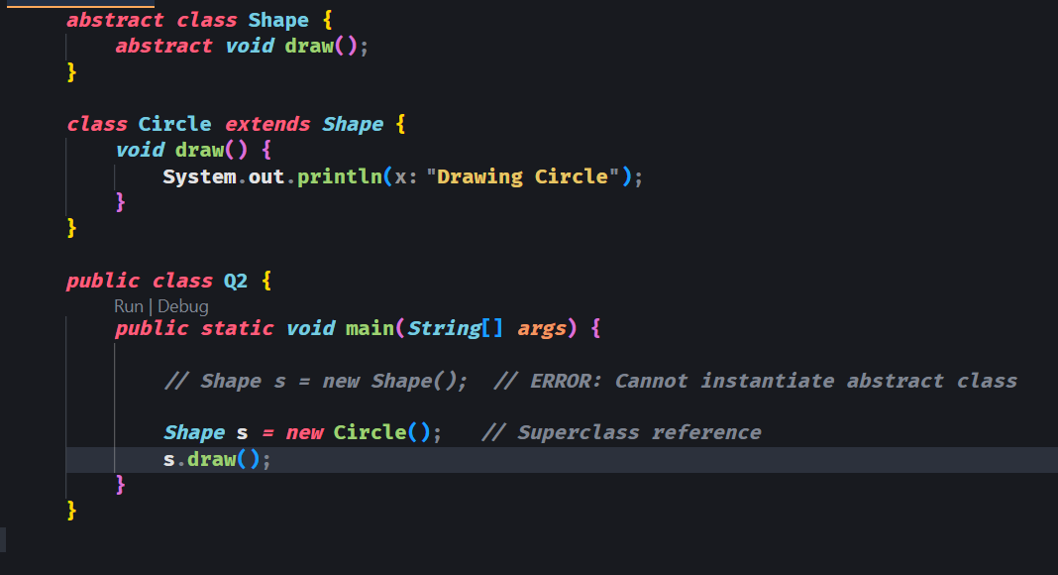

OUTPUT:

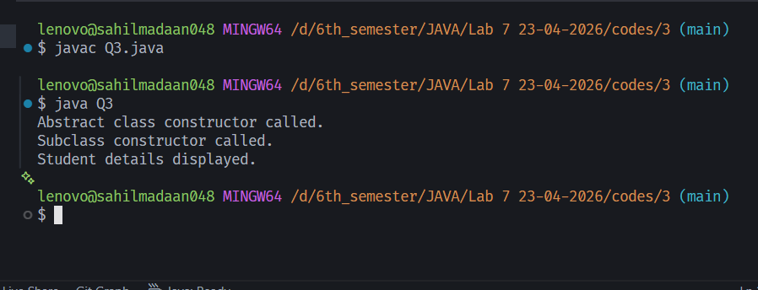

LAB 7
- Write a program to demonstrate that Abstract classes can have constructors and are called during object creation of subclasses.
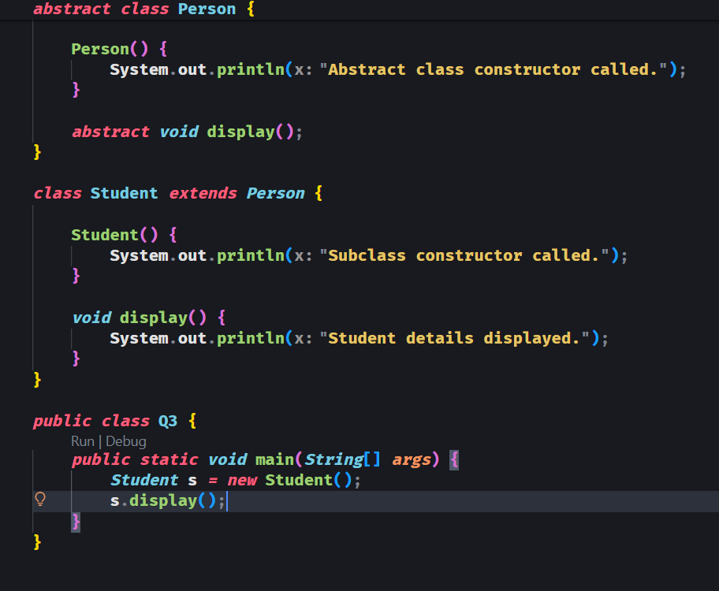

OUTPUT:

OUTPUT:

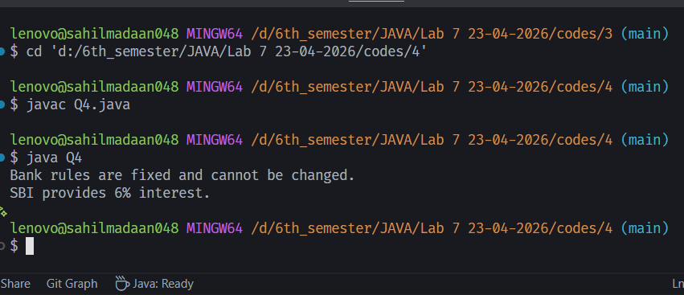

LAB 7
- Write a program to demonstrate the use of final methods inside an abstract class and show that they cannot be overridden.

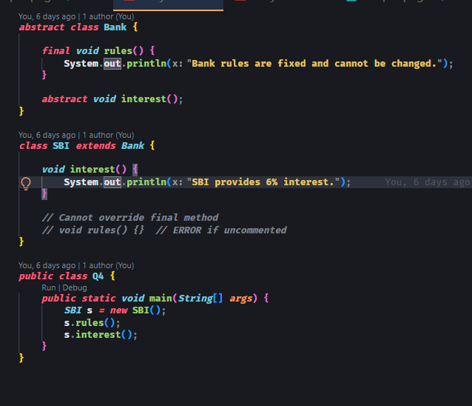

OUTPUT:

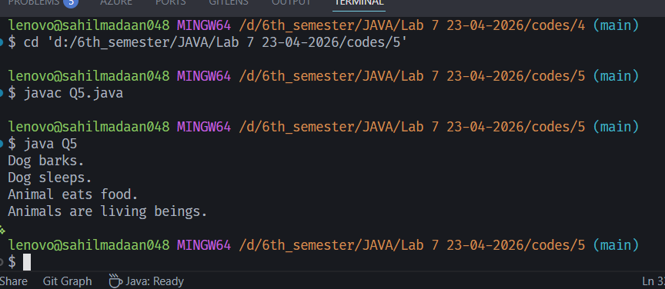

LAB 7
- Create an interface Animal with abstract methods sound() and sleep() and having default and static methods, and implement it in other classes.

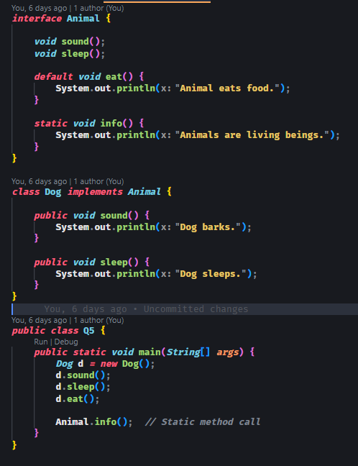

OUTPUT:
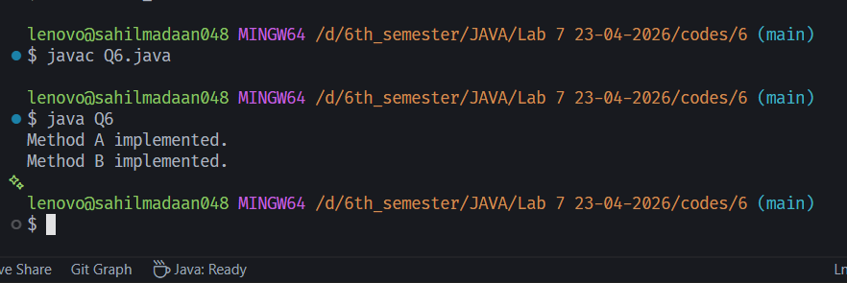

LAB 7
- Write a program where an interface is extended by another interface and implemented by a class.
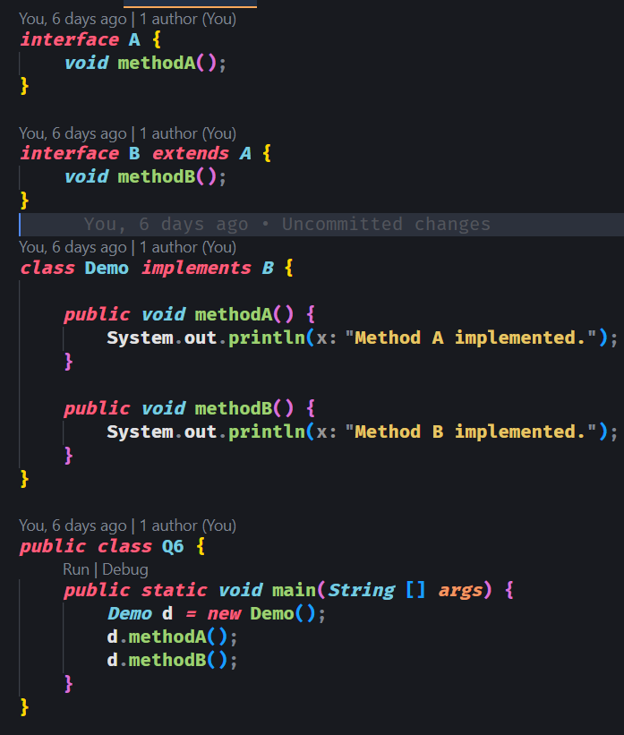

OUTPUT:



LAB 7
- Develop a program where a class implements an interface but does not override all methods and hence must be declared abstract.
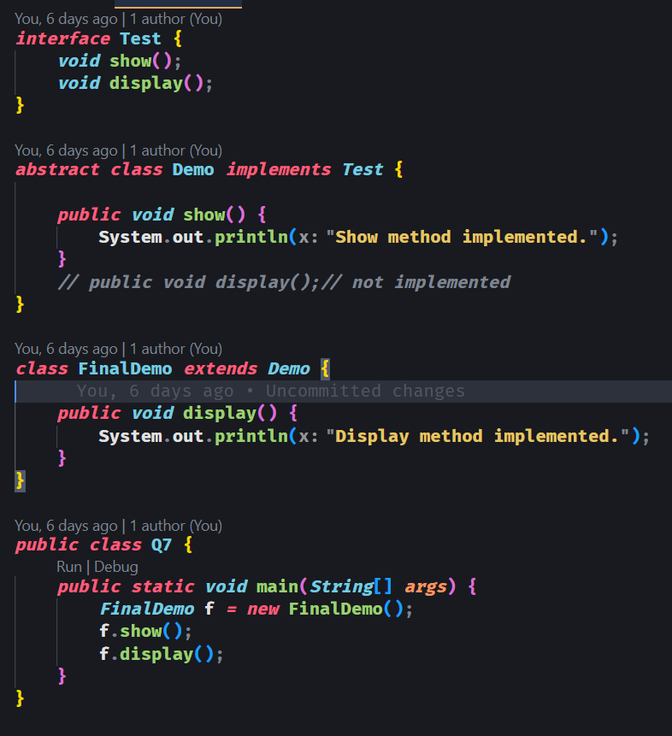

OUTPUT:

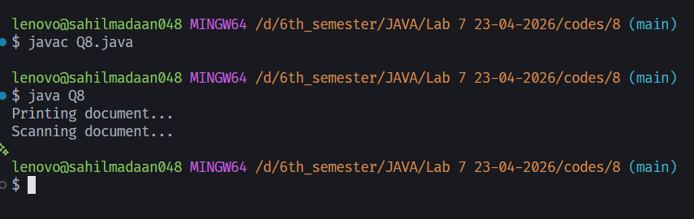

LAB 7
- Write a Program in which an abstract class providing implementation (implements) to an interface, and a concrete class extends the abstract class to provide the implementation to the abstract class.
